**R Code for Examples in the book**

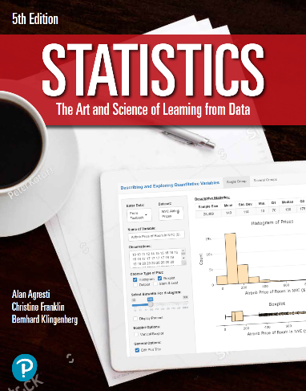

***“Statistics: The Art and Science of Learning from Data”***

**by Agresti, Franklin and Klingenberg, 5th edition**

**Chapter 2**

**Example 15: Cereal Sodium Data – The Quartiles**

## Read in Sodium values:

sodium <- c(0, 340, 70, 140, 200, 180, 210, 150, 100, 130, 140, 180, 190, 160,290, 50, 220, 180, 200, 210)

## To find the Quartiles:

quantile(sodium)

## 0% 25% 50% 75% 100%   
## 0.0 137.5 180.0 202.5 340.0